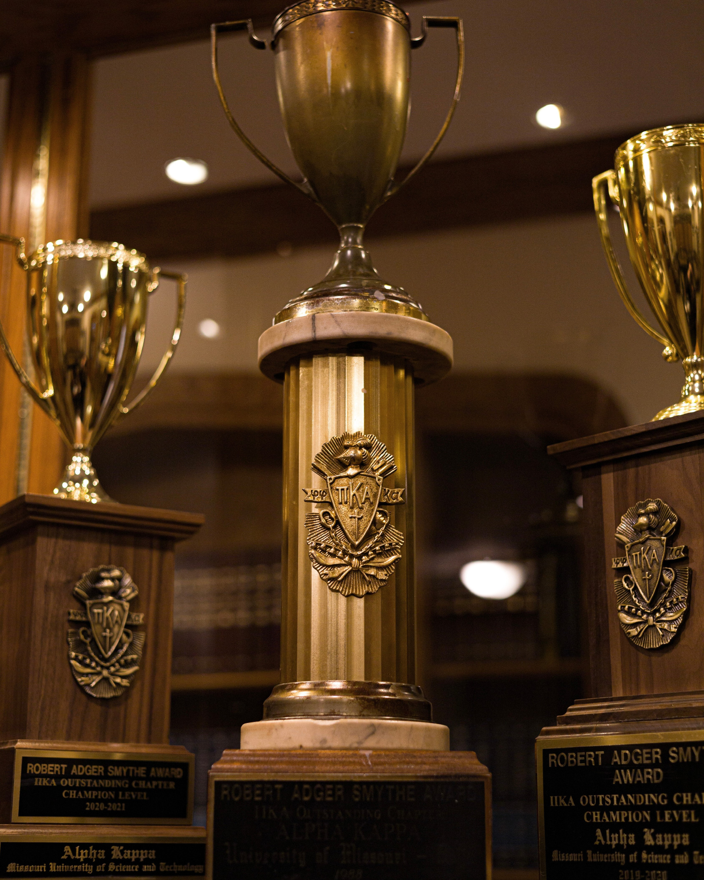


Awards and Achievements
Second Most Awarded Chapter of Pi Kappa Alpha in the Nation as of 2023
Smythe Award: Award given to the Top 10 Percent of all 225+ Pike
Chapters Nationwide. Received this Award 17 of the last 19 years
$100,000 in Scholarships Awarded to the Chapter Annually by the Alpha
Kappa Educational Foundation
Greek Week 2022 1st Place
Greek Week 2019 1st Place
Greek Week 2018 1st Place
Greek Sing 2022 4th Place
2021 Smythe National Fraternity Award
2020 Smythe National Fraternity Award
2022 Level 2 Recruitment Recognition
2021 Best Interior Project Award
2011-2020 100+ Man Chapter Award
2021 International Work Day award
2020 Athletics Award
1994-2021 Orians Excellence Award
Intramurals 2018-2019 2nd Place
Intramurals 2017-2018 1st Place
Intramurals 2016-2017 1st Place
2006-2022 100% Phi Phi Kappa Alpha Club Award
2022 Pike U 25 Man Commitment Award
17 year recipient of International Scholarship Plaque Award

